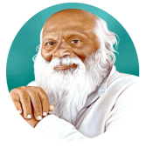
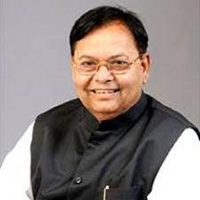
Rayat Shikshan Sanstha’s
Dr. Patangrao Kadam Mahavidyalaya, Ramanandnagar (Burli)
Department of Political Science
POs, PSOs and COs
Class | Course Name | PO1 | PO2 | PO3 | PO4 | PO5 | PO6 | PO7 | PO8
B.A. I | Indian Constitution P. I | 45.18 | 40.67 | 45.18 | 54.22 | 36.15 | 40.67 | 45.18 | 47.44
B.A. I | Indian Government P. II | 55.92 | 55.78 | 44.63 | 44.63 | 53.55 | 44.63 | 44.63 | 44.63
B.A.II. | Political Process in India P. III | 52.59 | 70.12 | 58.43 | 70.12 | 52.59 | 43.83 | 70.12 | 52.59
B.A.II. | Indian Political Thought- 1 P. IV | 57.55 | 51.80 | 69.06 | 69.06 | 34.53 | 46.04 | 46.04 | 69.06
B.A.II. | Public Administration P. V | 52.55 | 45.05 | 30.03 | 60.06 | 50.05 | 45.05 | 60.06 | 50.05
B.A.II. | Indian Political Thought - 2 P. VI | 54.18 | 72.24 | 54.18 | 0.00 | 72.24 | 36.12 | 0.00 | 54.18
B.A.III. | Local Self Government in Maharashtra P. VII | 56.52 | 33.91 | 56.52 | 59.34 | 56.52 | 33.91 | 56.52 | 59.34
B.A.III. | Public Administration P. VIII | 58.63 | 35.18 | 58.63 | 52.77 | 58.63 | 35.18 | 70.36 | 58.63
B.A.III. | Political TheoryP. IX | 45.49 | 50.54 | 33.42 | 53.07 | 37.90 | 50.54 | 30.32 | 53.07
B.A.III. | Public Administration P. X | 62.82 | 62.82 | 56.54 | 62.82 | 75.38 | 56.54 | 56.54 | 62.82
B.A.III. | Intrenational Politics P. XI | 28.56 | 48 | 48 | 57.72 | 28.56 | 48 | 48.51 | 57.72
B.A.III. | Comparative Politics P. XII | 50.15 | 60.18 | 30.09 | 45.135 | 50.15 | 60.18 | 30.09 | 40.12
B.A.III. | Western Political Thought - 1 P. XIII | 47.48 | 94.96 | 94.96 | 47.48 | 47.48 | 94.96 | 94.96 | 47.48
B.A.III. | Modern Political Concept Paper XIV | 77.77 | 59.25 | 71.10 | 74.07 | 77.77 | 59.25 | 69.19 | 74.07
B.A.III. | Politics and Movement in Maharashtra Paper XV | 48.53 | 53.92 | 64.70 | 32.35 | 49.78 | 53.92 | 64.70 | 32.35
B.A.III. | Foreign Policy if India Paper XVI | 66.56 | 49.92 | 41.60 | 49.92 | 66.56 | 49.92 | 39.936 | 49.92
B.A.III. | Comparative Government Paper XVII | 66.56 | 49.92 | 41.60 | 49.92 | 66.56 | 49.92 | 39.94 | 49.92
B.A.III. | Western Political Thought - 2 Paper XVIII | 66.56 | 49.92 | 41.6 | 49.92 | 66.56 | 49.92 | 39.936 | 49.92
2025 - 26

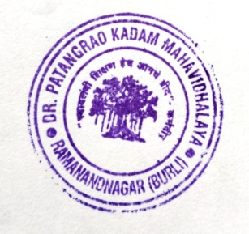

Rayat Shikshan Sanstha’s
Dr. Patangrao Kadam Mahavidyalaya, Ramanandnagar (Burli)
Department of Political Science
POs, PSOs and Cos2025 - 26

Class | Course Name | PO1 | PO2 | PO3 | PO4 | PO5 | PO6 | PO7 | PO8
B.A. I | Indian Constitution P. I | 45.18 | 40.67 | 45.18 | 54.22 | 36.15 | 40.67 | 45.18 | 47.44
B.A. I | Indian Government P. II | 55.92 | 55.78 | 44.63 | 44.63 | 53.55 | 44.63 | 44.63 | 44.63
In Graph

Rayat Shikshan Sanstha’s
Dr. Patangrao Kadam Mahavidyalaya, Ramanandnagar (Burli)
Department of Political Science
POs, PSOs and COs
2025 - 26

Class | Course Name | PO1 | PO2 | PO3 | PO4 | PO5 | PO6 | PO7 | PO8
B.A. II | Political Process in India P. III | 52.59 | 70.12 | 58.43 | 70.12 | 52.59 | 43.83 | 70.12 | 52.59
B.A. II | Indian Political Thought- 1 P. IV | 57.55 | 51.80 | 69.06 | 69.06 | 34.53 | 46.04 | 46.04 | 69.06
B.A. II | Public Administration P. V | 52.55 | 45.05 | 30.03 | 60.06 | 50.05 | 45.05 | 60.06 | 50.05
B.A. II | Indian Political Thought - 2 P. VI | 54.18 | 72.24 | 54.18 | 0.00 | 72.24 | 36.12 | 0.00 | 54.18
In Graph

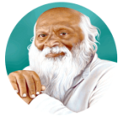
Rayat Shikshan Sanstha’s
Dr. Patangrao Kadam Mahavidyalaya, Ramanandnagar (Burli)
Department of Political Science
POs, PSOs and COs
Class | Course Name | PO1 | PO2 | PO3 | PO4 | PO5 | PO6 | PO7 | PO8
B.A.III | Local Self Government in Maharashtra P. VII | 56.52 | 33.91 | 56.52 | 59.34 | 56.52 | 33.91 | 56.52 | 59.34
B.A.III | Public Administration P. VIII | 58.63 | 35.18 | 58.63 | 52.77 | 58.63 | 35.18 | 70.36 | 58.63
B.A.III | Political TheoryP. IX | 45.49 | 50.54 | 33.42 | 53.07 | 37.90 | 50.54 | 30.32 | 53.07
B.A.III | Public Administration P. X | 62.82 | 62.82 | 56.54 | 62.82 | 75.38 | 56.54 | 56.54 | 62.82
B.A.III | Intrenational Politics P. XI | 28.56 | 48 | 48 | 57.72 | 28.56 | 48 | 48.51 | 57.72
B.A.III | Comparative Politics P. XII | 50.15 | 60.18 | 30.09 | 45.135 | 50.15 | 60.18 | 30.09 | 40.12
B.A.III | Western Political Thought - 1 P. XIII | 47.48 | 94.96 | 94.96 | 47.48 | 47.48 | 94.96 | 94.96 | 47.48
B.A.III | Modern Political Concept Paper XIV | 77.77 | 59.25 | 71.10 | 74.07 | 77.77 | 59.25 | 69.19 | 74.07
B.A.III | Politics and Movement in Maharashtra Paper XV | 48.53 | 53.92 | 64.70 | 32.35 | 49.78 | 53.92 | 64.70 | 32.35
B.A.III | Foreign Policy if India Paper XVI | 66.56 | 49.92 | 41.60 | 49.92 | 66.56 | 49.92 | 39.936 | 49.92
B.A.III | Comparative Government Paper XVII | 66.56 | 49.92 | 41.60 | 49.92 | 66.56 | 49.92 | 39.94 | 49.92
B.A.III | Western Political Thought - 2 Paper XVIII | 66.56 | 49.92 | 41.6 | 49.92 | 66.56 | 49.92 | 39.936 | 49.92

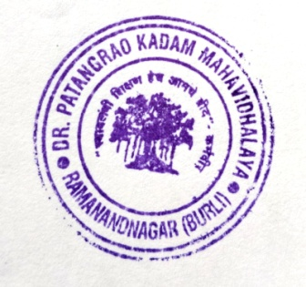

In Graph

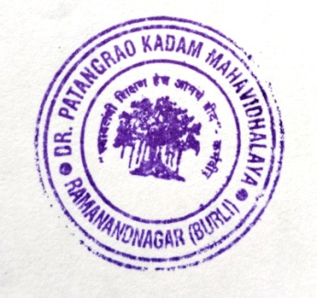

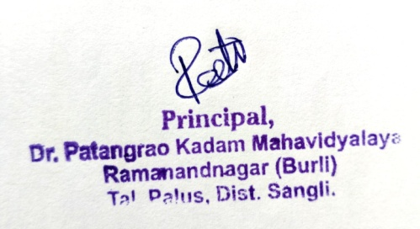
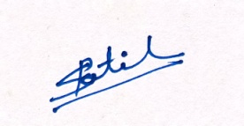

Head
Department of Political Science

