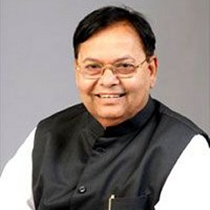
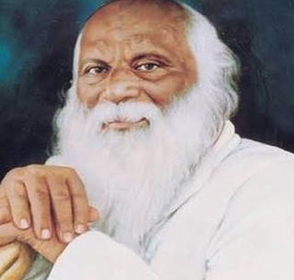
Rayat Shikashan Sanstha’s

Dr.Patangrao Kadam Mahavidyalaya, Ramanandnagar (Burli)
Department of Political Science
Under MoU
Panchayati Raj Institution Visit Report (ग्रामपंचायत अभ्यास भेट)
Date: 06 December 2025
Department of Political Science, Dr. Patangrao Kadam Mahavidyalaya, Ramanandnagar, for the students of B.A. II to observe the functioning of local self-government institutions. the visit took place at the Gram Panchayat, Ramanandnagar. the Sarpanch and all Gram Panchayat members were present during the visit. the students were given detailed information about how the Gram Panchayat functions and they observed the practical implementation of various schemes and administrative processes. this hands-on exposure helped them understand the real-world working of the Panchayati Raj system.
The visit was conducted under the guidance of Dr. Shital Patil Head of Department along with Prof. Rajesh Pawar Prof. Shailesh Kamble and Prof. Sarita Nikam who were present along with the students.
Conclusion:
- Students gained insight into the functioning of the Gram Panchayat.
- They observed the implementation of various schemes by the local self-government in real-time.

Beneficiaries – 06 students

